NGP Backplane CARD

Hardware Requirement Specification
Rev-B

24-APR-2013

Ownership Disclaimer
This document contains proprietary and confidential material that is the sole property of Compressor Controls Corporation. The information contained herein is intended for internal use by Compressor Controls Corporation employees and is not intended for distribution outside of the company. As an unpublished work of trade secrets, the recipient shall keep this document confidential. Any re-use, copying, or distribution, either in whole or in part, of this material without the express written consent of Compressor Controls Corporation is strictly forbidden.
Copyright © 2011 by Compressor Controls Corporation. All rights reserved.

Revision History

Rev. | Date | Revised By | Description
A | 5-Feb-13 | Muthuvelu.D | REVA Release
A | 24-Apr-13 | Ajesh John | REVB relaese

Approvals

Approved by: Date: _______________
Approved by: Date: _______________
Approved by: Date: _______________
Approved by: Date: _______________
Approved by: Date: _______________
Approved by: Date: _______________

TABLE OF CONTENTS

1 Introduction 5
1.1 Purpose 5
1.2 Audience 5
1.3 Scope 5
1.4 Acronyms 5
1.5 References 6
2 General Description 7
2.1 System Overview 7
2.2 Product Perspective 9
2.3 Product Functions 10
2.4 Bidirectional Traceability of Requirements 10
2.5 Operational Concepts and Scenarios 10
2.6 Acceptance Criteria 11
2.7 Regulatory standards 11
2.8 Assumptions 11
2.9 Dependencies 11
3 Block Diagram 12
4 Specific Requirements 13
4.1 Functional Requirements 13
4.2 Interface connector Requirements 14
4.2.1 Power Interface to Backplane 14
4.2.2 PCC Board interface 14
4.2.3 APP Board interface 14
4.2.4 IES Board interface 15
4.2.5 IOP-AM Board interface 15
4.2.6 IOP-DM Board interface 15
4.2.7 FTA-AM Board interface 16
4.2.8 FTA-DM Board interface 16
4.2.9 External Serial Port Card interface 16
4.2.10 External TCP/IP Ethernet Card interface 17
4.2.11 ECAT board interface 17
4.3 Mechanical Specification 17
4.4 Material Specification 17
4.5 Environmental Specification 18
4.6 Schematic requirements 18
4.7 Layout requirements 18
4.8 Testing requirements 18
5 Not in scope 18
6 Deliverables 19
7 Appendix 19

Introduction

Purpose
The objective of the document is to describe the hardware requirement specifications of backplane to be designed for New Generation Platform (NGP) Hardware system.

Audience
The intended users of this document are hardware developers, software developers, test engineers, project leaders / program managers and management of Mindteck and Compressor Controls Corporation.

Scope
The scope of the document is to capture the hardware requirement specifications of the backplane to be designed for the NGP hardware system. The specifications and the technical requirements are derived from the available product specifications, project proposal and based on the interactions with CCC.

This document describes the hardware design requirement of backplane, which shall include capturing the requirements on the importance of the backplane in the system. The main power input to the NGP system through the backplane power connector. The various boards namely Power Conversion Card (PCC), Application Processor (APP) board, Industrial Ethernet Switch (IES) board, I/O Processor (IOP) boards, Field Termination Card (FTA Card), SAC, External TCP/IP Ethernet Card (EEC) are interfaced on the backplane. These requirements are derived based on the requirements of NGP hardware system and also based on the reference documents provided by CCC.

Acronyms
Acronym | Definition
APP | Application Processor Card
NGP | New Generation Platform
PCC | Power Conversion Card
IES | Industrial Ethernet Switch
IOP | Input/Output Processor
EEC | External TCP/IP Ethernet Card (EEC)
CAC | Communication Accessory Card

References
[1] Detailed Functional Specification for NGP Hardware, Part 1, Rev-3
[2] System Study for New Generation Platform Electronics and Bring-up, Rev-1

General Description

System Overview
New Generation Platform (NGP) is a fully redundant, duplex, highly available, fault tolerant control system intended to handle a number of digital, analog and frequency I/Os in industrial applications. Below is the system block diagram of NGP.

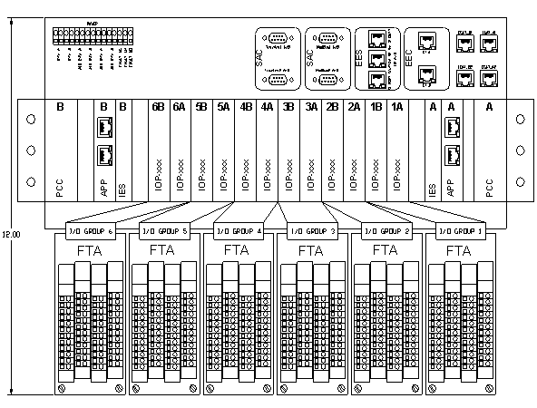Here is the list of different electrical components in the system and their brief description.

APP
This is the main processing unit in the system. This runs the main application and does monitoring and control of the overall system. There will be a maximum of 2 such cards in an NGP system.

IOP (Digital and Analog)
These are the processors cards which handle digital, analog and frequency I/Os based on the type of IOP card installed on the backplane slot. There will be a maximum of 12 (6 pairs) such cards in an NGP system.

IES
This is the EtherCAT switch card used to interface between different APP and IOP modules. There will be a maximum of 2 such cards in an NGP system.

PCC
This is power conversion card. The input power (redundant 24VDC) to the system first comes to this card. This card does the ORing, filtering, protection and other voltage conversion. There will be a maximum of 2 such cards in an NGP system

FTA (Digital and Analog)
These are the field terminal cards, where all the field loads are connected to. These are electrically interfaced to IOP cards.

CAC
These are the set of communication (Ethernet, RS-485) cards used for interface to the external devices.

Backplane
All the above mentioned boards plugged onto the backplane and they communicate to each other through the backplane.

Product Perspective
Backplane shall be like the backbone of the entire NGP hardware system. Even though this backplane may not be playing the major role in the functionality of the entire system, this shall provide the connectivity between various boards present in the system. The backplane shall be the base of the NGP hardware on which the various boards shall be plugged using appropriate connectors. The various boards plugged on the backplane are PCC, APP, IES, IOP, FTA and communication accessory cards. The backplane mainly avoids the cabling between various boards for the communication between them.

The communication accessory cards shall include External TCP/IP Ethernet Card (EEC) and External Serial Port Card also called as SAC.

NGP shall accept the external redundant 24VDC power supplies through a 14 positions terminal block mounted on the backplane to power the entire chassis. There shall be an isolated input terminal for the external redundant 24VDC that shall be routed to power the analog FTA boards. Similarly there shall be an isolated input terminal for the external redundant 24VDC that shall be routed to power the digital FTA boards.

As mentioned the backplane supports the communication between various boards plugged onto the backplane. The major interfaces supported are the EtherCAT interface, Ethernet interface, RS485 serial interface and other digital and analog interfaces.

Product Functions
The backplane board shall provide below functions.

    - Physical support for various boards present in the systems. These boards shall be plugged on to the respective connectors mounted on the backplane.
    - Receives power to the NGP system through the suitable 14 positions terminal block mounted on the backplane.
    - Distribution of power from the PCC board to various boards present in the system
    - Support for the redundancy of the system.
    - Support the electrical connectivity for one EtherCAT interface from APP board to IES board and second EtherCAT interface from APP board to ECAT board.
    - Support the electrical connectivity for one EtherCAT interface from each of the IES board to ECAT board.
    - Support the electrical connectivity for twelve EtherCAT channels from each of the IES board to each of the 12 IOP boards.
    - Support for 4 channels of 4 wire RS485 from the APP board to the External Serial Port Card.
    - Support the electrical connectivity for two Ethernet channel from each of the APP board to the External TCP/IP Ethernet Card
    - Support to interface the IOP board signal to FTA boards.
    - APP, IES, SAC and IOP cards are hot swappable.

Bidirectional Traceability of Requirements
Bidirectional traceability of requirements shall be available through Requirements Traceability Matrix, which shall be prepared by Mindteck during the design phase.

Operational Concepts and Scenarios

The backplane shall be the base plate of the NGP system – Hardware, where it provides the mechanical support to various boards present in the system. The back plane shall also provides the electrical connectivity support to communicate between the various boards in the systems. This helps in avoiding the cabling between the boards. The various connectors from FCI shall be mounted on the backplane for plugging the daughter boards.

There shall not be any active or passive electronics parts mounted on the backplane PCB except capacitors. The intension shall be backplane board shall not be reworked at any moment of time. Also the maximum possible interconnections are provided between the boards, so that in future also there shall not be any necessity to respin the backplane PCB.

Acceptance Criteria
Mindteck shall design, develop and deliver the hardware meeting the functionalities as detailed in section 4.0

Regulatory standards
Design shall follow below standards
- CE
- CSA
- ATEX

Assumptions
    - Backplane shall provide only the electrical connections between various boards. No active or passive electronics components shall be mounted on the backplane PCB expect decoupling capacitors.

Dependencies

    - CCC shall ensure availability of
- About 10% time from an CCC’s representative for addressing queries, reviews and acceptance
- Timely inputs, reviews and approvals
- Assistance in the finalization of all the requirements specification documents
- Validation testing and approval of prototypes

Block Diagram
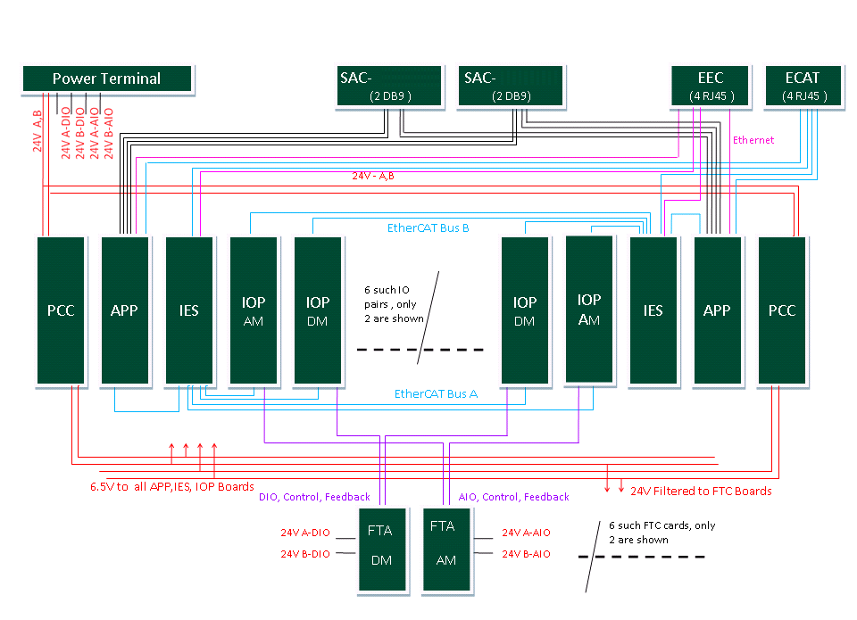

Specific Requirements
Following sections detail out the individual requirements...

Functional Requirements
    - Physical support for various daughter boards present in the systems. These boards are plugged on to the respective connectors mounted on the backplane.
    - Receives power to the NGP system through the suitable power connector mounted on the backplane.
    - Distribution of power from the PCC board to various daughter boards present in the system
    - Support for the redundancy of the system.
    - Support for the electrical connectivity for one EtherCAT interface from APP board to IES board and second EtherCAT interface from APP board to ECAT board.
    - Support for the electrical connectivity for one EtherCAT interface from each of the IES board to ECAT board.
    - Support for the electrical connectivity for twelve EtherCAT channels from each of the IES board to each of the 12 IOP boards.
    - Support for 2 channels of 4 wire RS485 from the APP board to the External Serial Port Card.
    - Support for 2 channels of 2 wire RS485 from the APP board to the External Serial Port Card.
    - Support for two Ethernet channel from each of the APP board to the External TCP/IP Ethernet Card
    - Support to interface the IOP board signal to FTA boards.
    - APP, IES and IOP cards are hot swappable.
    - Load share implementation on 6.5V_A and 6.5V_B

Interface connector Requirements

Power Interface to Backplane

Power connector is used to draw the power from the external power supply module. The power connector used shall be 14 positions terminal block. NGP shall accept the external redundant 24VDC power through this interface and supplies to all chassis cards. This connector also has isolated input terminals for external redundant 24VDC for powering the field side of Analog Input transmitters at the I/O terminals. Similarly there shall be isolated input terminals for external redundant 24VDC for powering the field side of Digital I/O at the I/O terminals.

The detailed pins description of power interface connector to the backplane is described in Appendix A.

PCC Board interface

The PCC board shall be plugged on the backplane through PCC board interface connector. This board receives redundant 24VDC power (range 18V-36V) and provides 5VDC (30A) output and also provides filtered 24VDC output. There are two such connectors, one for A side PCC and second for B side PCC.

The detailed pins description of PCC board interface connector to the backplane is described in Appendix A.

APP Board interface

The APP board shall be plugged on the backplane through APP board interface connectors. For mounting each side APP board on the backplane two signals connectors, one power connector and two guide pins shall be used. Out of two signal connectors one is 54 pins Airmax series Press-Fit connector from. The other signal connector is 72 pins Airmax series Press-Fit connector from FCI.

The various signals interfaced between the backplane and the APP board are detailed in the attached spreadsheet in Appendix A.

IES Board interface

The IES board shall be plugged on the backplane through IES board interface connectors. For mounting each side IES board on the backplane two signals connectors, one power connector and two guide pins shall be used

The various signals interfaced between the backplane and the IES board are detailed in the attached spreadsheet in Appendix A.

IOP-AM Board interface

There shall be maximum of 6 pairs of IOP-AM boards in the NGP system. If the number of IOP-AM boards pairs used are less than 6 , then the remaining IOP pairs shall be of type IOP-DM boards. Each of these IOP-AM boards shall be plugged on to the backplane through IOP interface connector.

The each of the IOP-AM board shall communicate with the IES board through EtherCAT interface. There are two channels of EtherCAT from IOP-AM, one to each side of the NGP system.

For mounting each of the IOP-AM board on the backplane two signals connectors, one power connector and a guide pin shall be used. The signal connectors used shall be of 72 pins Airmax series Press-Fit connector from The 6 pin power connector from FCI is used.

The various signals interfaced between the backplane and the IOP board are detailed in the attached spreadsheet in Appendix A.

IOP-DM Board interface

There shall be maximum 6 pairs of IOP-DM boards in the NGP system. If the number of IOP-DM boards pairs used are less than 6 , then the remaining IOP pairs shall be of type IOP-AM boards. Each of these IOP-DM boards shall be plugged onto the backplane through IOP interface connectors.

The each of the IOP-DM board shall communicate with the IES board through EtherCAT interface. There are two channels of EtherCAT from IOP-DM, one to each side of the NGP system.

For mounting each of the IOP-DM board on the backplane two signals connectors, one power connector and a guide pin shall be used. The signal connectors used shall be of 72 pins Airmax series Press-Fit connector from The 6 pin power connector from FCI is used

The various signals interfaced between the backplane and the IOP board are detailed in the attached spreadsheet in Appendix A.

FTA-AM Board interface

Field I/O wiring shall terminate to a card called FTA, that plugs into the backplane directly without any cables. These cards shall be unique to the chassis mounted I/O card that may connect to. There shall be a common connector, pin out and routing from the field termination cards to I/O card backplane slots regardless of type (IOP-AM or IOP-DM).

There shall be maximum of 6 FTA-AM boards in the NGP system. Each of these FTA-AM boards is plugged on to the backplane through FTA interface connector.

For mounting each of the IOP-DM board on the backplane two signals connectors shall be used. The signal connectors used shall be of 150 pins Airmax series Press-Fit connector from FCI

The various signals interfaced between the backplane and the FTA board are detailed in the attached spreadsheet in Appendix A.

FTA-DM Board interface

There shall be maximum of 6 FTA-DM boards in the NGP system. Each of these FTA-DM boards shall be plugged on to the backplane through FTA interface connector.

For mounting each of the IOP-DM board on the backplane two signals connectors shall be used. The signal connectors used shall be of 150 pins Airmax series Press-Fit connector from FCI.

The various signals interfaced between the backplane and the FTA board are detailed in the attached spreadsheet in Appendix A.

External Serial Port Card interface

The external serial port card is the communication accessory card that provides connectivity from the chassis to the external devices via RS-485 communications.

There are two External Serial port cards in the system. Four full duplex RS485 channels, two from each of the APP board are terminated to each ESC. To the other ESC four half duplex RS-485 channels, two from each of the APP board are terminated.

In both the cases four serial ports, two from the “A” APP (Port 1A and 2A) and two from the “B” APP (Port 1B and 2B) are taken through the backplane to ESC.

For mounting each of the external serial port card on the backplane a 54 pins Airmax series Press-Fit connector from FCI shall be used

The detailed pins description is provided in Appendix A.

External TCP/IP Ethernet Card interface

The EEC provides RJ-45 connectors for four Ethernet ports, two from the “A” APP and two from the “B” APP via backplane connector. The detailed pins description is provided in Appendix A.

For mounting the EEC board on the backplane a 54 pins Airmax series Press-Fit connector from FCI shall be used

ECAT board interface

The EACT board provides RJ-45 connectors for four ECAT ports.

For mounting the EEC board on the backplane a 54 pins Airmax series Press-Fit connector from FCI shall be used

Mechanical Specification

- Backplane PCB size shall be 431.8mm x 304.7mm.
- PCB Thickness : 3 mm

Material Specification
- The PCB material shall be FR4. The backplane board shall be 10 layers board to accommodate all the parts and their dense interconnectivity.
Components shall be RoHS compliant wherever feasible

Environmental Specification

- For all IC’s and PCB components temperature rating shall be -40°C to +85°C.
- 0 to 60°C Operating range
- Storage temperature shall be -40°C to +85°C.
- Humidity shall be 5 to 95% , non-condensing.

Schematic requirements

Schematic entry shall be done using PADS Logic v-9.0 or higher
Note: The detailed Schematics requirements/ guidelines shall be provided in the separate document.

Layout requirements

Layout shall be done using PADS v-9.0 or higher

Note: The detailed Layout requirements/ guidelines shall be provided in the separate document.

Testing requirements

- Mindteck shall prepare the detailed test reports and presented to CCC for review and approval
- CCC shall conduct acceptance testing on receipt of the PCB assemblies as per agreed schedule

Not in scope

- User manual, tutorial or any other user documentation
- Certification, environmental, ATEX testing, EMI/EMC testing

Deliverables

Mindteck shall deliver the following hardware deliverables as per the project plan for CCC review and acceptance…

- Hardware Requirements Specifications document
- Hardware Design Document
- Backplane board schematics design files
- Board Layout files & Gerber files
- Backplane board Bill of Materials
- Tested prototypes
- Test reports

Appendix

Backplane connectors interface signals details.

